Println(“hello world”);

123;

if var == 2 then

var1 = readint("enter a number");

var2 = readint("enter another number");

avg = (var1 + var2) / 2;

println("the average of these numbers is: " avg);

elif var == 3 then

var1 = readint("enter a number");

var2 = readint("enter another number");

var3 = readint("enter another number");

avg = (var1 + var2 + var3) / 3;

println("the average of these numbers is: " avg);

elif var == 4 then

var1 = readint("enter a number");

var2 = readint("enter another number");

var3 = readint("enter another number");

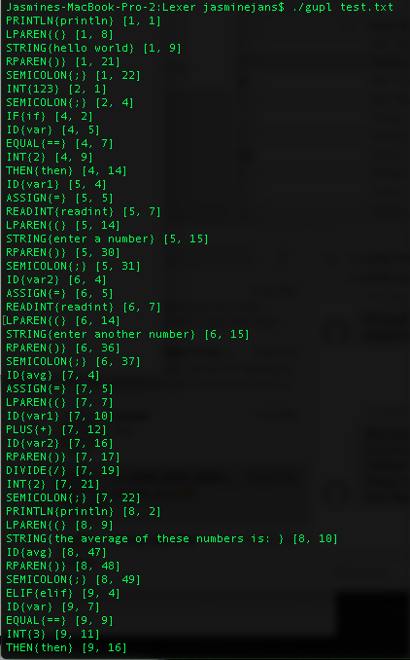 var3 = readint("enter another number");

avg = (var1 + var2 + var3 + var4) / 4;

println("the average of these numbers is: " avg);

else

println("this is not a valid input");

